* **Write note on a Cloud Deployment Models? (6/7 Marks)**

**Ans :**

“**Cloud Computing is a model for enabling convenient, on-demand network access to a shared pool of configurable computing resources (e.g., networks, servers, storage, applications, and services) that can be rapidly provisioned and released with minimal management effort or service provider interaction.”**

# Types of Cloud Computing :

A cloud deployment model represents a specific type of cloud environment, primarily distinguished by ownership, size, and access.There are four common cloud deployment models:

* [Public Clouds](http://whatiscloud.com/cloud_deployment_models/public_clouds)
* [Community Clouds](http://whatiscloud.com/cloud_deployment_models/community_clouds)
* [Private Clouds](http://whatiscloud.com/cloud_deployment_models/private_clouds)
* [Hybrid Clouds](http://whatiscloud.com/cloud_deployment_models/hybrid_clouds)

## Public Clouds

A *public cloud* is a publicly accessible cloud environment owned by a third-party cloud provider. The IT resources on public clouds are usually provisioned via the previously described cloud delivery models and are generally offered to cloud consumers at a cost or are commercialized via other avenues (such as advertisement).

The cloud provider is responsible for the creation and on-going maintenance of the public cloud and its IT resources. Many of the scenarios and architectures explored in upcoming chapters involve public clouds and the relationship between the providers and consumers of IT resources via public clouds.

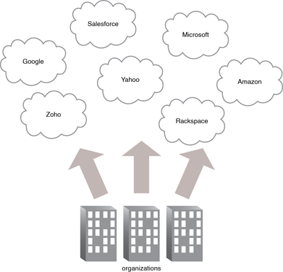

## Community Clouds

A community cloud is similar to a public cloud except that its access is limited to a specific community of cloud consumers. The community cloud may be jointly owned by the community members or by a third-party cloud provider that provisions a public cloud with limited access. The member cloud consumers of the community typically share the responsibility for defining and evolving the community cloud (Figure 1).

Membership in the community does not necessarily guarantee access to or control of all the cloud's IT resources. Parties outside the community are generally not granted access unless allowed by the community.

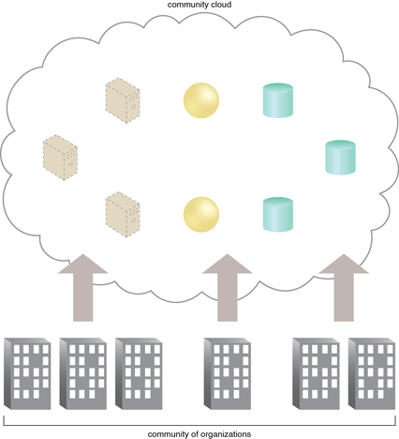

## Private Clouds

A private cloud is owned by a single organization. Private clouds enable an organization to use cloud computing technology as a means of centralizing access to IT resources by different parts, locations, or departments of the organization. When a private cloud exists as a controlled environment, the problems described in the Risks and Challenges section do not tend to apply.

The use of a private cloud can change how organizational and trust boundaries are defined and applied. The actual administration of a private cloud environment may be carried out by internal or outsourced staff.

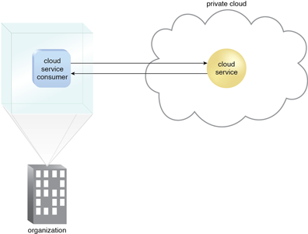

With a private cloud, the same organization is technically both the cloud consumer and cloud provider. In order to differentiate these roles:

* a separate organizational department typically assumes the responsibility for provisioning the cloud (and therefore assumes the cloud provider role)
* departments requiring access to the private cloud assume the cloud consumer role

It is important to use the terms "on-premise" and "cloud-based" correctly within the context of a private cloud. Even though the private cloud may physically reside on the organization's premises, IT resources it hosts are still considered "cloud-based" as long as they are made remotely accessible to cloud consumers. IT resources hosted outside of the private cloud by the departments acting as cloud consumers are therefore considered "on-premise" in relation to the private cloud-based IT resources.

## Hybrid Clouds

A hybrid cloud is a cloud environment comprised of two or more different cloud deployment models. For example, a cloud consumer may choose to deploy cloud services processing sensitive data to a private cloud and other, less sensitive cloud services to a public cloud. The result of this combination is a hybrid deployment model (Figure 1).

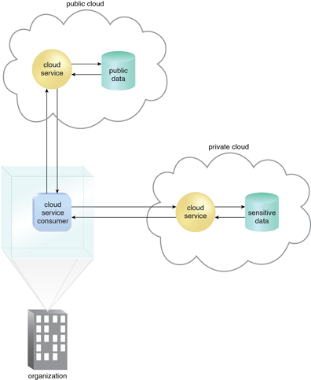

Hybrid deployment architectures can be complex and challenging to create and maintain due to the potential disparity in cloud environments and the fact that management responsibilities are typically split between the private cloud provider organization and the public cloud provider.